Journal of Endocrinology & Diabetes

About the Journal:
The Journal of Endocrinology & Diabetes is an international, peer-reviewed journal committed to publishing high-quality research that advances the understanding of endocrine, metabolic, and diabetic disorders. The journal serves as a global platform for clinicians, researchers, academicians, and healthcare professionals to disseminate innovative scientific findings, clinical insights, and emerging therapeutic approaches that contribute to improving patient care and public health. By maintaining rigorous peer-review standards and promoting scientific integrity, the journal strives to foster excellence in endocrine and diabetes research.
The journal welcomes original research articles, review articles, systematic reviews, case reports, short communications, and clinical studies across a wide range of topics, including diabetes mellitus, thyroid disorders, obesity, metabolic syndrome, pituitary and adrenal diseases, reproductive and pediatric endocrinology, osteoporosis, lipid metabolism, endocrine oncology, and precision medicine. Through the publication of impact and evidence-based research, the Journal of Endocrinology & Diabetes aims to facilitate scientific collaboration, support continuous medical education, and drive innovation in the prevention, diagnosis, and management of endocrine and metabolic diseases worldwide.
Latest News:
New advances in precision endocrinology:-
Researchers continue to expand the role of precision medicine in endocrine care through personalized hormone therapies, AI-assisted clinical decision-making, and genomics-guided treatment strategies for diabetes, thyroid disorders, and other endocrine diseases. Recent reviews also highlight the growing integration of digital health technologies into endocrine practice.

Growing research on endocrine disorders and metabolic health:-
Recent publications have reported advances in thyroid disease, obesity management, reproductive endocrinology, adrenal disorders, and the relationship between viral infections and autoimmune diabetes. Scientists are also investigating novel mechanisms that may influence the development and progression of Type 1 diabetes.

.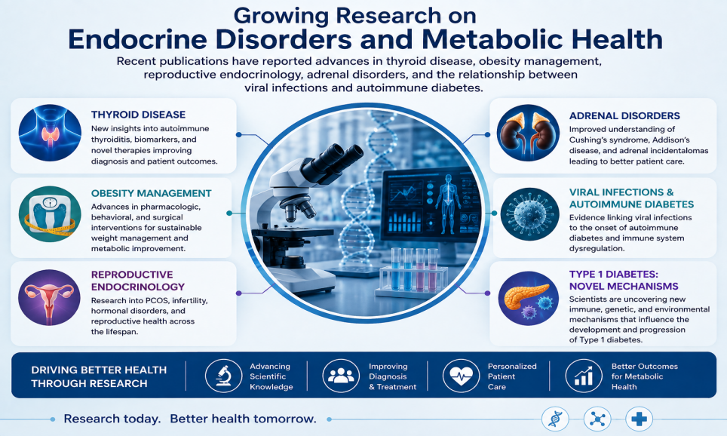

Updated Type 2 Diabetes treatment guidance:-
The American Association of Clinical Endocrinology (AACE) released updated recommendations emphasizing patient-centered treatment, earlier use of GLP-1 receptor agonists and SGLT2 inhibitors for appropriate patients, and individualized therapy based on cardiovascular, kidney, and metabolic risk profiles.

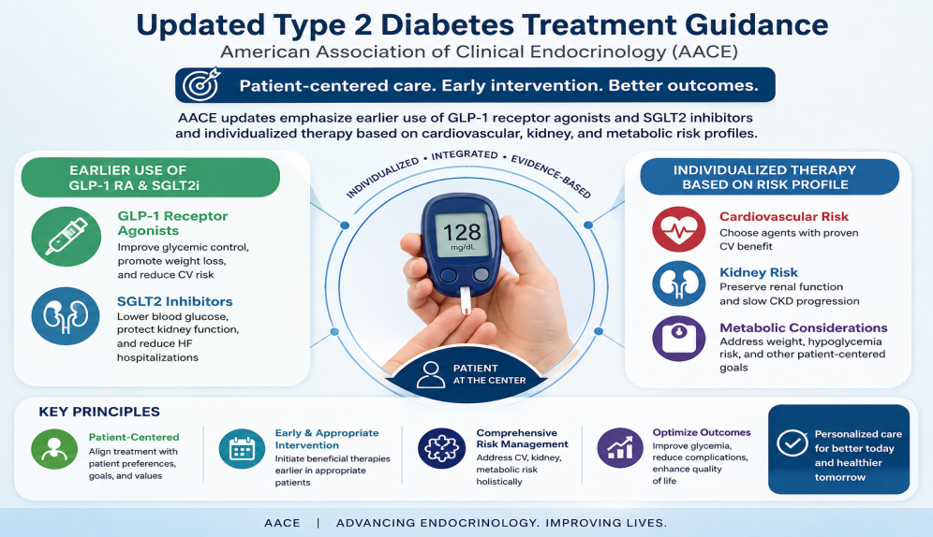

Artificial intelligence improves diabetes management:-
New research has introduced AI-based frameworks capable of more accurate blood glucose prediction and personalized diabetes management. These tools aim to improve continuous glucose monitoring, predict hypoglycemic events, and support individualized treatment decisions for people with Type 1 and Type 2 diabetes.
Scientific Topics:

- Clinical Endocrinology
Clinical endocrinology focuses on the diagnosis, treatment, and long-term management of disorders affecting the endocrine glands and hormone balance. It plays a vital role in improving patient outcomes through evidence-based care for conditions such as diabetes, thyroid diseases, adrenal disorders, and metabolic syndromes.
- Diabetes & Glucose Metabolism
Diabetes and glucose metabolism research focuses on understanding how the body regulates blood sugar and developing innovative strategies for the prevention, diagnosis, and treatment of diabetes. Advances in this field continue to improve glycemic control, reduce complications, and enhance the quality of life for individuals living with metabolic disorders.
- Neuroendocrinology and Pituitary
Neuroendocrinology and pituitary research explores the interactions between the nervous and endocrine systems, focusing on hormone regulation, pituitary disorders, and hypothalamic function.
Advances in this field are improving the diagnosis and treatment of hormonal and neurological conditions.
- Pediatric Endocrinology
Pediatric endocrinology focuses on the diagnosis and management of hormonal disorders affecting infants, children, and adolescents. It addresses conditions such as growth disorders, diabetes, thyroid diseases, puberty-related disorders, and metabolic abnormalities to support healthy development.
- Thyroid Disorders and Cancer
Thyroid disorders and cancer research focuses on the prevention, diagnosis, and treatment of benign and malignant thyroid conditions.
Advances in molecular diagnostics and targeted therapies are improving patient outcomes and personalized care.
6. Nutrition and metabolism
Nutrition and metabolism research examines how nutrients influence energy balance, metabolic health, and disease prevention. Emerging studies are advancing personalized nutrition strategies to improve overall health and manage metabolic disorders.
7. Diabetes and Hypoglycemia
This field focuses on the prevention, diagnosis, and management of diabetes while addressing the causes and treatment of hypoglycemia. Ongoing research is driving innovations in glucose monitoring, personalized therapies, and improved metabolic health outcomes.
8. Artificial Intelligence: The Future for Diabetes Care
Artificial intelligence is revolutionizing diabetes care by enabling early risk prediction, personalized treatment strategies, and intelligent glucose monitoring. These innovations are improving clinical outcomes, optimizing disease management, and enhancing patient care.
9. COVID-19 Impacts in People with Diabetes
COVID-19 has highlighted the increased health risks faced by people with diabetes, emphasizing the importance of effective glycemic control and comprehensive disease management. Ongoing research continues to improve prevention, treatment, and long-term care strategies for this vulnerable population.
10. Reproductive Endocrinology
Reproductive endocrinology focuses on the hormonal regulation of reproductive health, fertility, and related disorders. Advances in this field are improving the diagnosis, treatment, and outcomes of endocrine conditions affecting reproduction.
11. Genomics in Endocrinology
Genomics in endocrinology explores the genetic basis of endocrine disorders to enable earlier diagnosis and more precise treatment strategies. Advances in genomic technologies are driving personalized medicine and improving patient care across a wide range of hormonal diseases.
12. Nanotechnology in Diabetes Treatment
Nanotechnology is advancing diabetes treatment through targeted drug delivery, improved glucose sensing, and innovative insulin delivery systems. These emerging technologies have the potential to enhance therapeutic efficacy, precision, and patient outcomes.
Editorial in Chief:
Mikhail G. Kolonin
University of Texas, Houston, USA
Biography:
Mikhail G. Kolonin, PhD, is a Professor at the McGovern Medical School, The University of Texas Health Science Center at Houston (UTHealth Houston), and Director of the Center for Metabolic and Degenerative Diseases. His research focuses on obesity, adipose tissue biology, metabolism, aging, and type 2 diabetes, with an emphasis on developing targeted therapies for metabolic diseases. Dr. Kolonin has authored numerous high-impact scientific publications and is internationally recognized for his contributions to metabolic research and translational medicine.
6 Articles are attached herewith….

